User Guide

To begin our character creation sheet direct your browser to <https://seangillick.github.io/DNDEasy/index.html>.

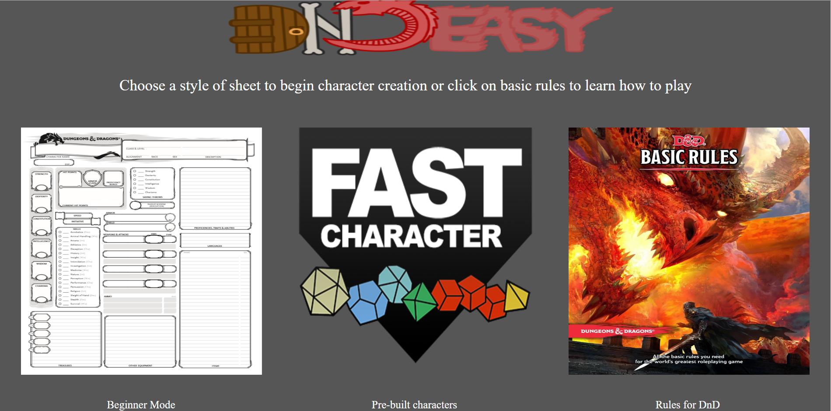

(landing page)

This landing page gives you three images that are all clickable. On the right is a link to DND’s basic rules, where newer players can look over advanced longer version of the rules.

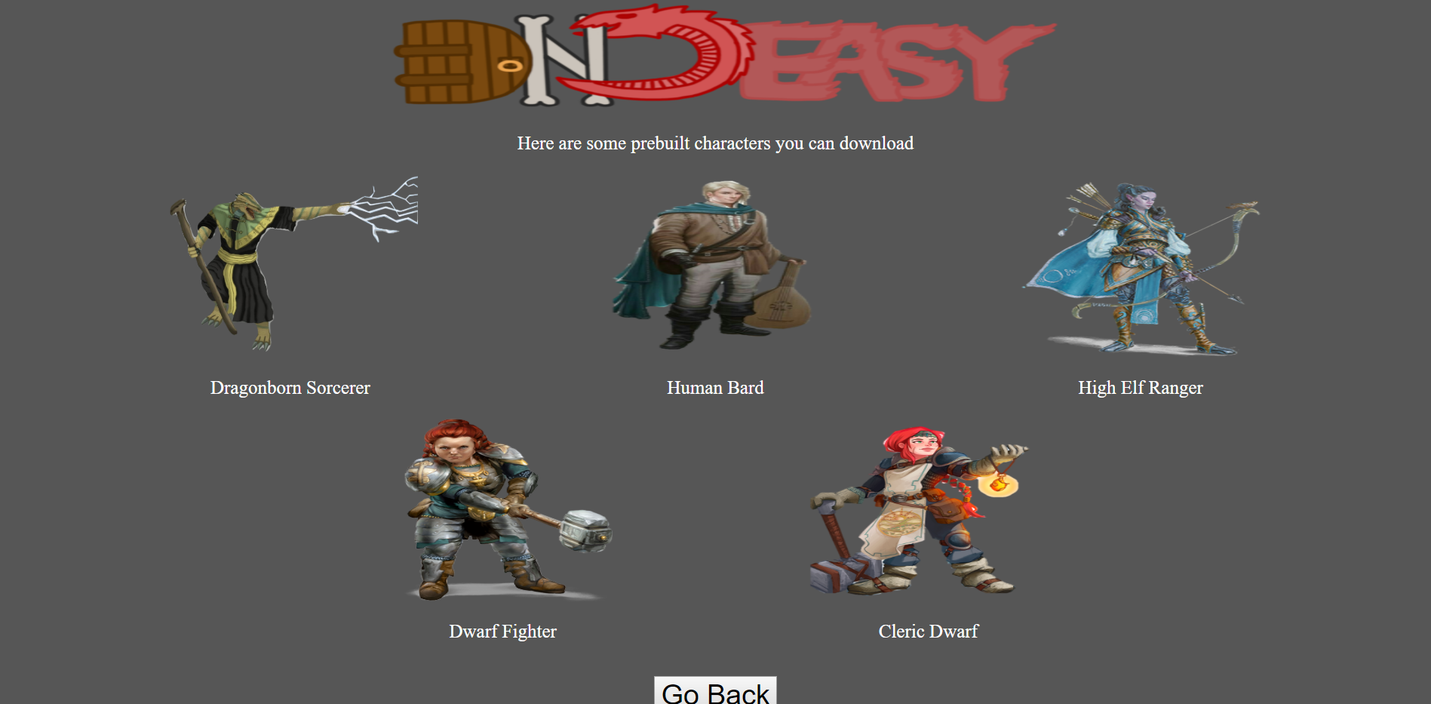

(premade characters)

The middle image on the landing page will redirect you to the page above. This page will allow the user to select their desired prebuilt character without having to make it themselves. After they have selected their prebuilt character it will prompt them for a download with their character sheet in a PDF format.

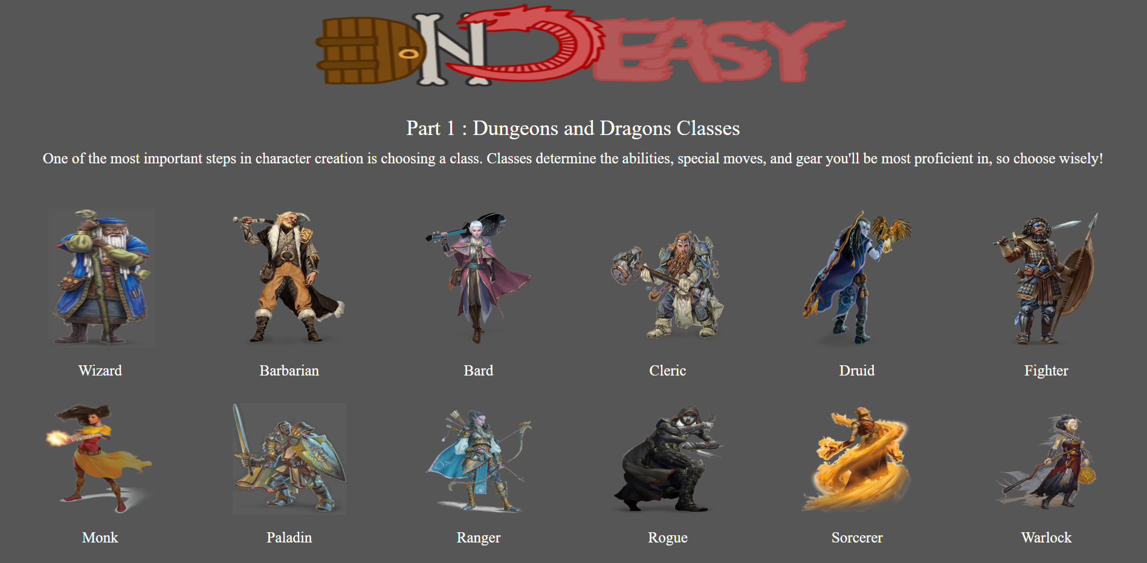

(Character sheet creation guide)

If you click on the left image on the landing page, it will bring you to the first step in the character creation guide. The first step takes you to a list of Dungeons and dragons Classes where you can select which class you would like to proceed with.

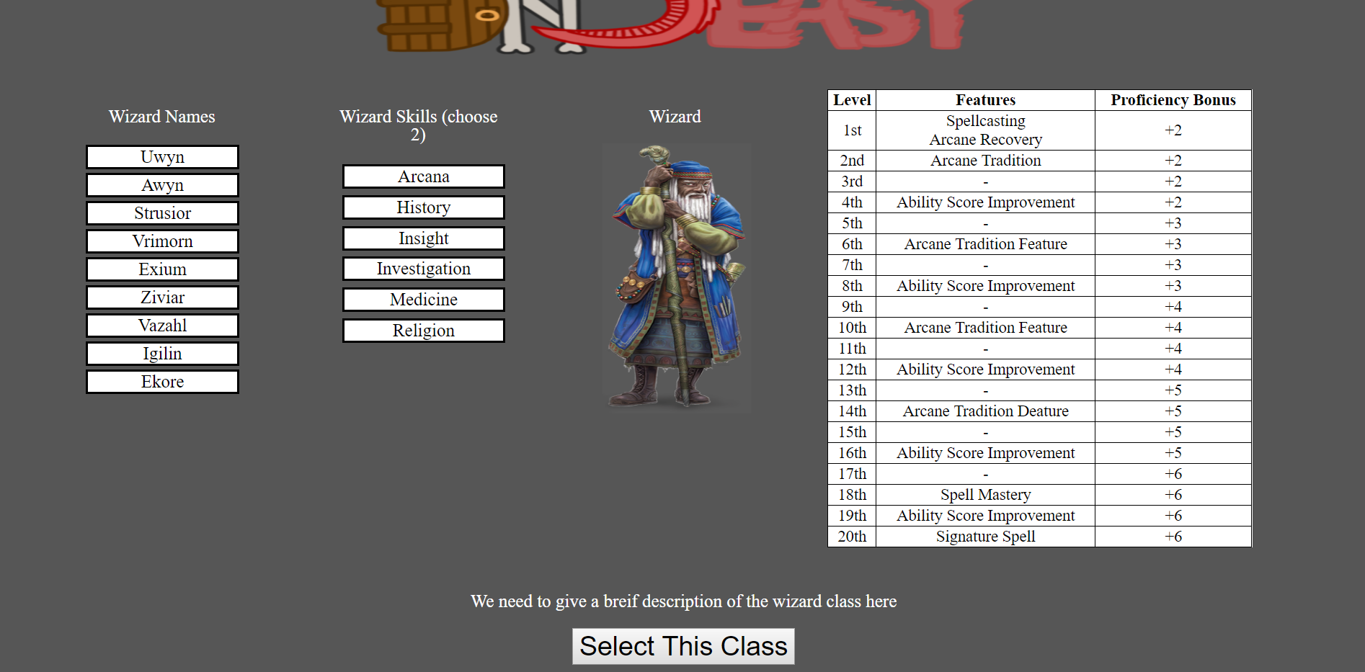

(Class description page)

This is an example of the wizard class. It shows names, skills, class features as a base overview to give the user basic information about what they are selecting. The button in the bottom that says “select this Class” will send the user to the next page and confirming they want to make this choice. This page will also allow the user to add two skills to their character and then add it to their character sheet.

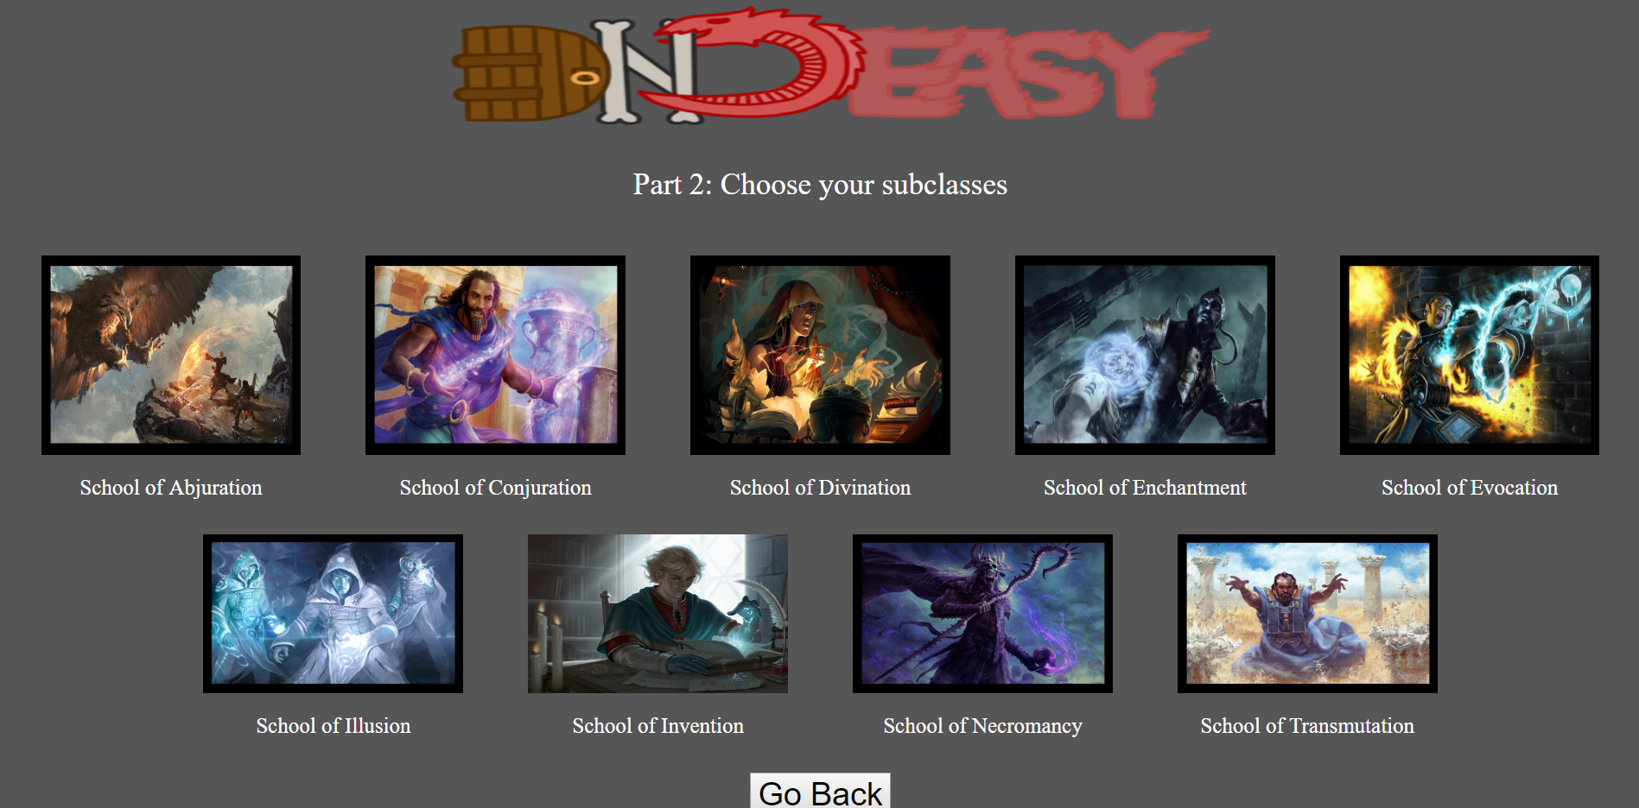

(Subclass page)

This page is simple, clicking on an image will send you to the subclass description page that will give you basic information on each subclass.

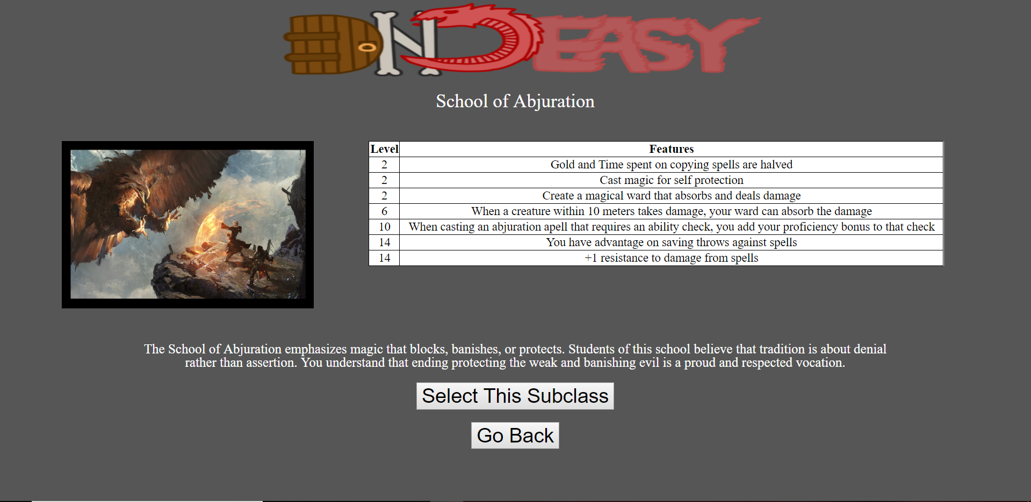

(Subclass description)

The Subclass page shows the user features about each subclass, allowing them to get a brief overview of basic information before they continue. This also allows them to go back if they do not want to select this subclass.

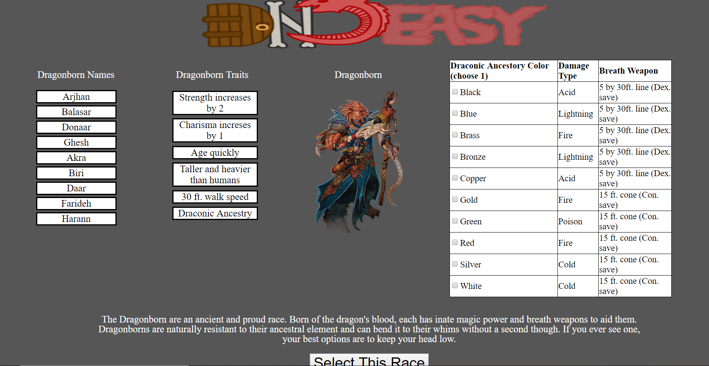

(Race Description)

The Race Description page allows the user to see the suggested Dragonborn names. The traits are also displayed on the page. Finally the user must select a Draconic Ancestory Color and the damage type and weapon for each is listed.

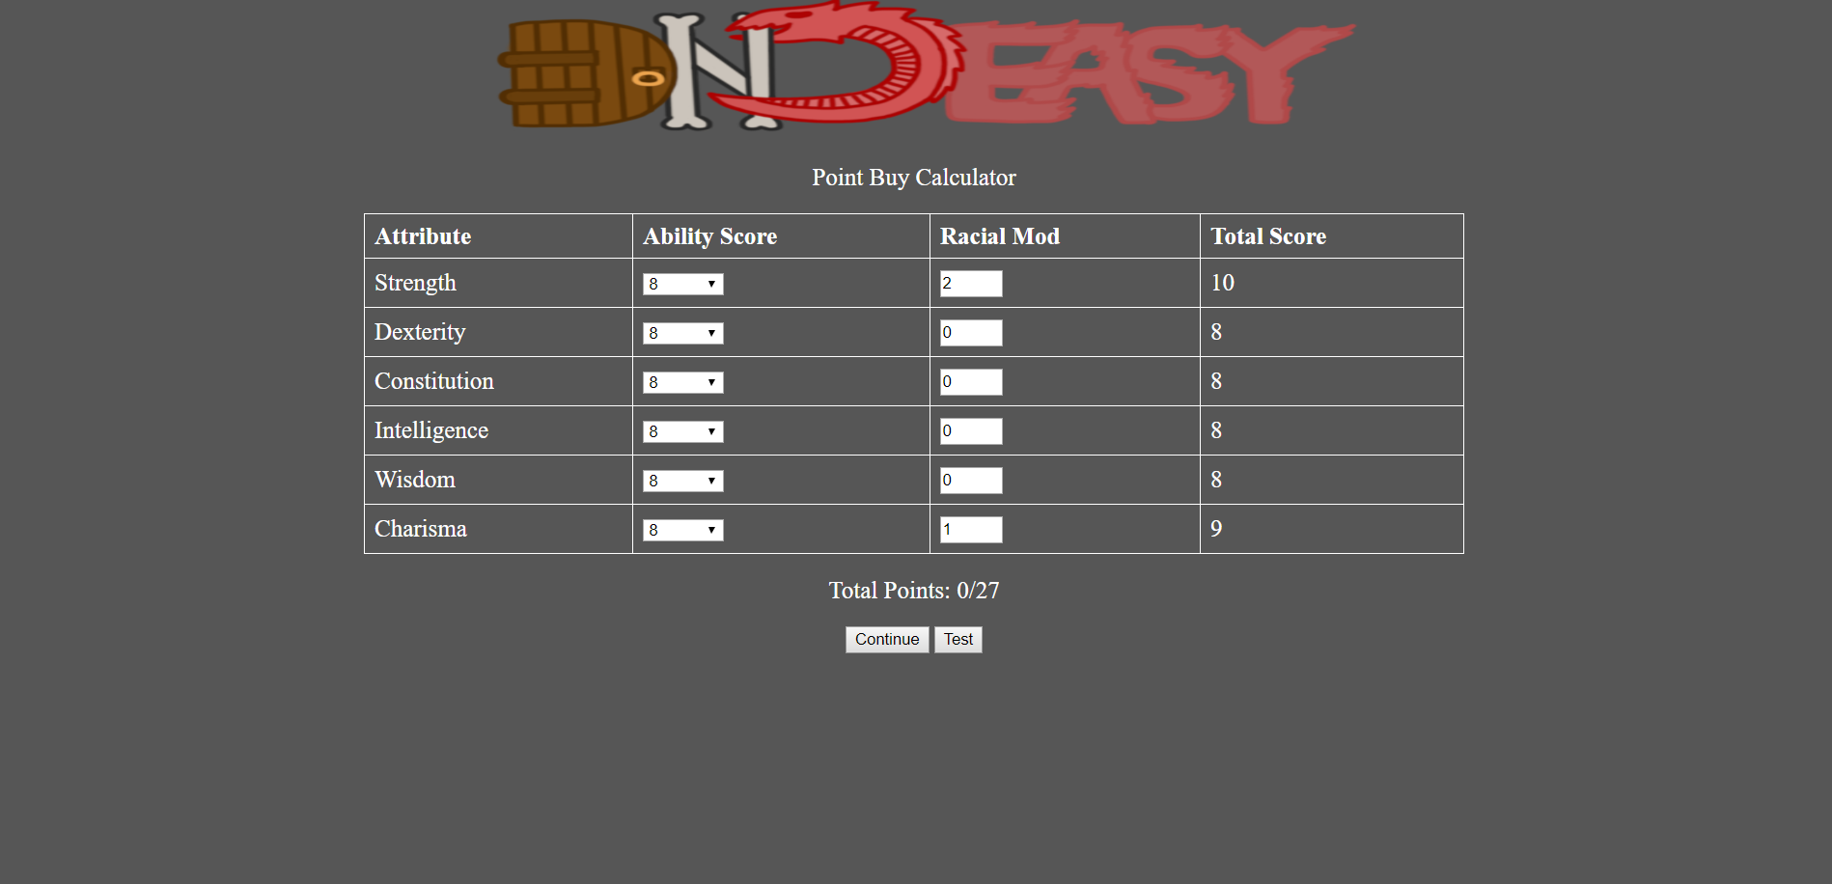

(Point Buy)

This page gives the user the ability to choose their skills.

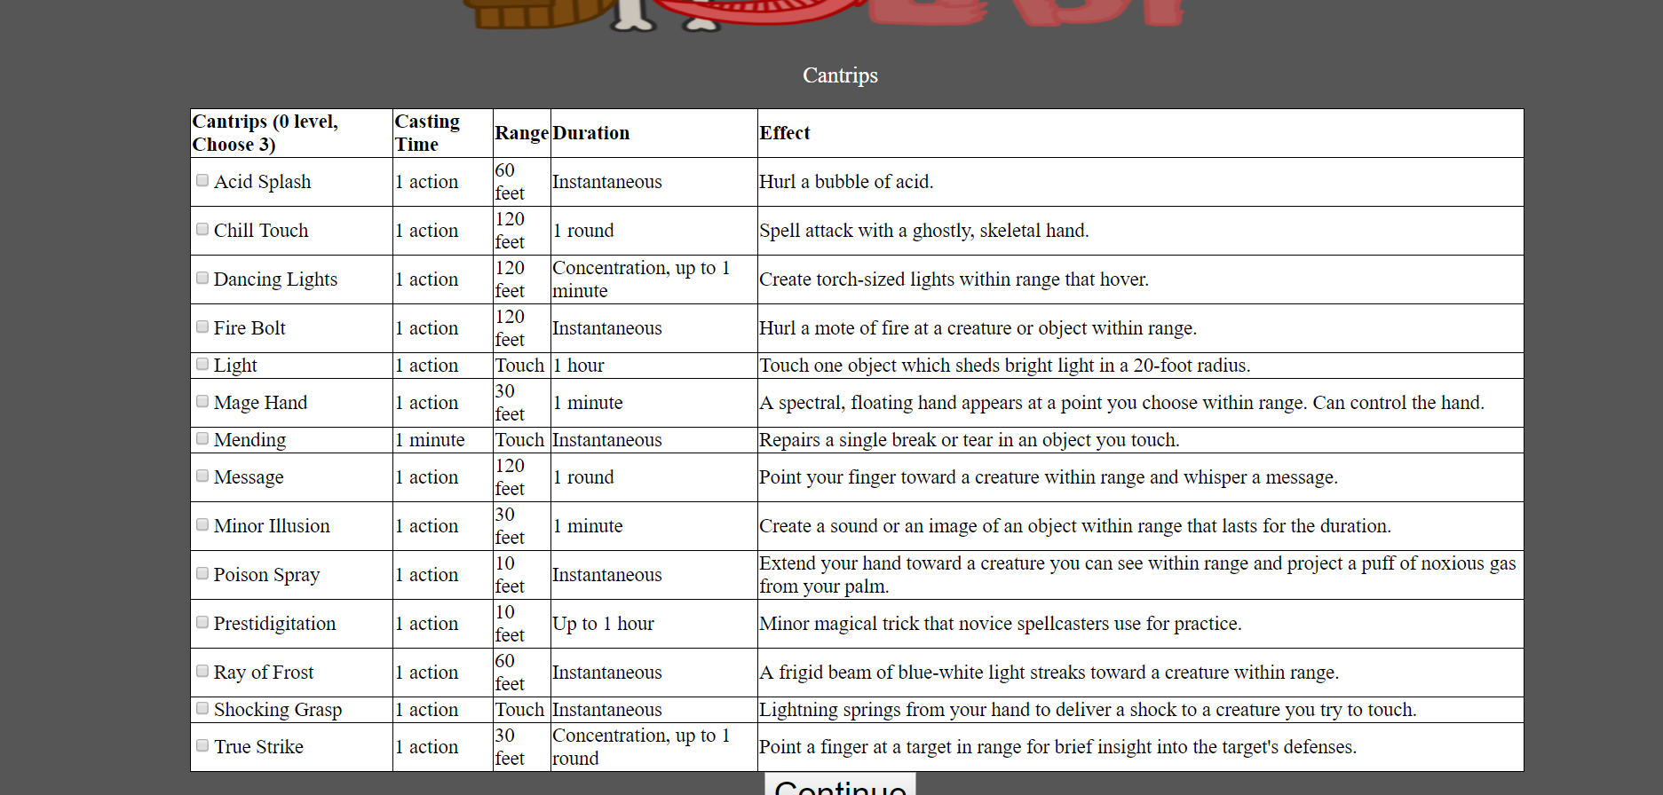

(Cantrips)

The Cantrips page is where the player will select three specific attacks their character can use. All of the details for each attack have been listed so it should be an easy process to choose the Cantrips. The casting time, action, duration, and effects have been listed for easy reference.

After the sheet has been printed, not all information has been given. There is still information you will need to add as you level up along with attacks that will be decided between you and the DM (Dungeon Master). There will be extra boxes that we recommend that you work with your DM to polish up your sheet and decide what you will need to finish up, for example there is a box for attacks there for your convenience. Also there is a section for currency that is decided by the DM before the game starts.